***Efficient Embedded Course***

**ASSIGNMENT**

**ADC LAB:**

**INFRARED PROXIMITY SENSOR**

**Issue 1.0**

Contents

1 Introduction 1

1.1 Lab overview 1

2 Requirements 1

3 Details 2

3.1 Hardware 3

3.1.1 Circuit Assembly 3

3.2 Software 4

4 Procedure 5

4.1 Basic Steps 5

4.2 Analysis 5

4.2.1 Ambient Light Analysis 5

4.2.2 Time Delay Analysis 5

4.2.3 Range Analysis 5

4.2.4 Calibration 6

# Introduction

## Lab overview

For this project, you will create a device that uses reflected infrared (IR) light to detect if an object is nearby.

# Requirements

In this lab, we will be using the following hardware and software:

* **Keil µVision5 MDK IDE**
  + Please see the included Getting Started with Keil guide on how to download and install Keil.
* **STM32 Nucleo-L552ZE-Q**
  + For more information, click [here](https://www.st.com/en/evaluation-tools/nucleo-l552ze-q.html).
* **Logic Analyzer or Oscilloscope** 
  + Required to monitor the interrupt signals
* **IR emitter (LED)**
* **IR detector (photo transistor)**

# Details

The proximity sensor uses an IR emitter (LED) and an IR detector (photo transistor) pointing in the same direction to determine if any object is reflecting IR energy from the LED.



Figure 1. Proximity sensor method of operation.

The proximity sensor works with a combination of hardware and software. Sensing occurs in two steps: First, the software must measure the IR light level (using IR-sensitive photo transistor Q1 and the analog to digital converter) when the IR-emitting LED is **turned off**. Second, the software must measure the IR light level when the IR LED is turned **on**. If the IR brightness level has increased, then there may be an object nearby reflecting the IR from D1 back to Q1. The signal strength is to be indicated by the RGB LED.

|  |  |  |
| --- | --- | --- |
| C:\Users\Alex\Documents\Teaching\Book Writin'\ARM Cortex M0Plus\Content\Analog IO\Project\no-obj.BMP   1. No object present | C:\Users\Alex\Documents\Teaching\Book Writin'\ARM Cortex M0Plus\Content\Analog IO\Project\mid-obj.BMP   1. Far object present | C:\Users\Alex\Documents\Teaching\Book Writin'\ARM Cortex M0Plus\Content\Analog IO\Project\near-obj.BMP   1. Near object present |

Figure 2. Oscilloscope screenshots showing IR Output Signal (upper trace) and IR Input Signal (lower trace).

As IR energy increases, this increases the conductivity of the photo transistor and lowers the output voltage. Also, note that the photo transistor has a slow response, as shown by the exponential decay curves in Figures 4b and 4c above.

You can verify that the IR LED is turned on by viewing it with a digital camera (e.g. in a cellphone), as these are sensitive to IR light.

## Hardware

Please see the Nucleo-L552ZE-Q User manual for the pinout of the Arduino-included Zio connectors for CN7, CN8, CN9 and CN10 using this link: https://www.st.com/resource/en/user_manual/um2581-stm32l5-nucleo144-board-mb1361-stmicroelectronics.pdf

### Circuit Assembly

Build the circuit on the breadboard as shown below.



Figure 3. Schematic diagram

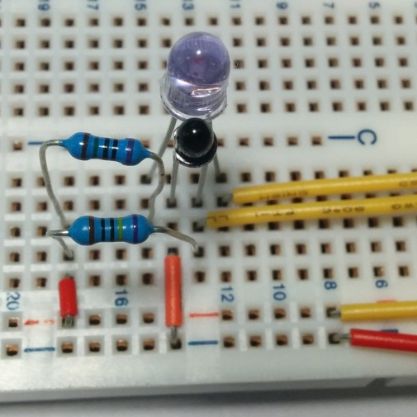

VCC

GND

PA_8

PA_0

Figure 4. Assembled circuit

Table 1. Components

|  |  |  |
| --- | --- | --- |
| **Identifier** | **Description** | **Image** |
| R1 | 150Ω (brown-green-black-black-silver) |  |
| R2 | 10kΩ (brown-black-black-red-silver). Note: increasing this will increase sensitivity if needed |  |
| D1 | Note that the flat side of the package marks the cathode (negative terminal, long lead) | C:\Users\Alex\Documents\Teaching\Book Writin'\ARM Cortex M0Plus\Content\IntroCourse\Modules\Analog IO\Lab\IR Components.jpg |
| Q1 | Note that the flat side of the package marks the emitter (negative terminal, short lead) | C:\Users\Alex\Documents\Teaching\Book Writin'\ARM Cortex M0Plus\Content\IntroCourse\Modules\Analog IO\Lab\IR Components.jpg |

Table 2. Signals and connections

|  |  |  |  |
| --- | --- | --- | --- |
| Signal name | Description | Direction | MCU |
| Dig. Out | Drive signal for IR LED D1 | Output | PA_8 |
| Analog In | IR brightness | Input | PA_0 |
| Vdd | 3.3V power supply | Power |  |
| GND | Ground | Power |  |

## Software

The control software has the following functions:

* Initialization function: configures GPIO pins and ADC input as needed.
* Delay function: performs delay loop based on function argument.
* Pick LEDs function: Lights RGB LED according to input argument (IR brightness difference).
* Measure IR function: measures difference in brightness caused by lighting LED. In order to reduce noise, average at least twenty measurements before each update of the LED color.
* Main function: Initializes system and then repeatedly calls measure IR, which is passed to the pick LEDs function.

# Procedure

## Basic Steps

1. Load the project into MDK and build it. Download it to the Nucleo-F401RE board in debug mode.
2. Add the following variables to the watch window. Enable periodic window updates in the View menu. Remember that only static variables can be monitored live.

* reads
* background_ir
* differences
* avg_diff

## Analysis

### Ambient Light Analysis

1. Disconnect the IR emitter. Is the photo transistor reading of IR brightness steady or does it vary? If so, how much and why?
2. Reconnect the IR emitter and monitor the IR difference reading. Shield the photo transistor from IR energy emitted from the side of the LED. Does this change the difference signal strength? If so, by how much and why?

### Time Delay Analysis

1. The sensitivity of the proximity sensor increases as you wait longer to sample the photo transistor’s voltage after changing the IRLED (see Figure 2 above). What is the impact of doubling the default on-time and off-time? Adjust the constants T_LED_ON and T_LED_OFF.

### Range Analysis

1. What is the maximum distance at which your sensor can reliably detect a sheet of paper? Your hand? Your thumb? Your arm?
2. Does the ambient light level make a difference? Try shading the receiver from room lighting.

### Calibration

1. Calibrate your code so that the RGB LED is lit according to object distance, shown below. Calibrate by adjusting the values in the array called threshold, declared in main.c. To ensure consistency, use the same object for all calibration and testing.
   * Green: No object within 20cm
   * Blue: 16-20 cm
   * Yellow: 12-16 cm
   * Red: 8-12 cm
   * Magenta: 4-8 cm
   * White: 0-4 cm